Comparison Report: AI Models for Requirement Extraction
In this series of experiments, five AI models, ChatGPT, Claude AI, Grok AI, DeepSeek, and Microsoft Copilot, were evaluated on their ability to extract functional and non-functional requirements from various Software Requirements Specification (SRS) documents. I assessed each model based on several key criteria: Coverage, Clarity, Traceability, Completeness, Redundancy, and AI Hallucination. This report provides a detailed comparison, highlighting the strengths and weaknesses of each model.
Key Evaluation Criteria
- Coverage: Measures how well the model identifies and captures all functional and non-functional requirements in the SRS document.
- Clarity: Assesses how readable, precise, and well-organized the requirements are.
- Traceability: Evaluates whether each requirement is linked back to its source in the original document.
- Completeness: Checks if the model includes all necessary details, such as actors, priorities, and constraints.
- Redundancy: Looks for any duplicated or unnecessary requirements in the extracted data.
- AI Hallucination: Measures the level of irrelevant or fabricated content produced by the model.

Overall Performance Comparison
Below is a summary of how each model performed across the evaluation criteria:
Model | Coverage | Clarity | Traceability | Completeness | Redundancy | AI Hallucination | Average Score
Claude AI | 100 | 95 | 100 | 100 | 85 | 98 | 93.3
DeepSeek | 95 | 85 | 100 | 95 | 95 | 97 | 88.3
Microsoft Copilot | 90 | 90 | 90 | 80 | 85 | 98 | 84.5
Grok AI | 85 | 80 | 75 | 75 | 80 | 95 | 79.4
ChatGPT | 85 | 90 | 70 | 80 | 90 | 95 | 80.4

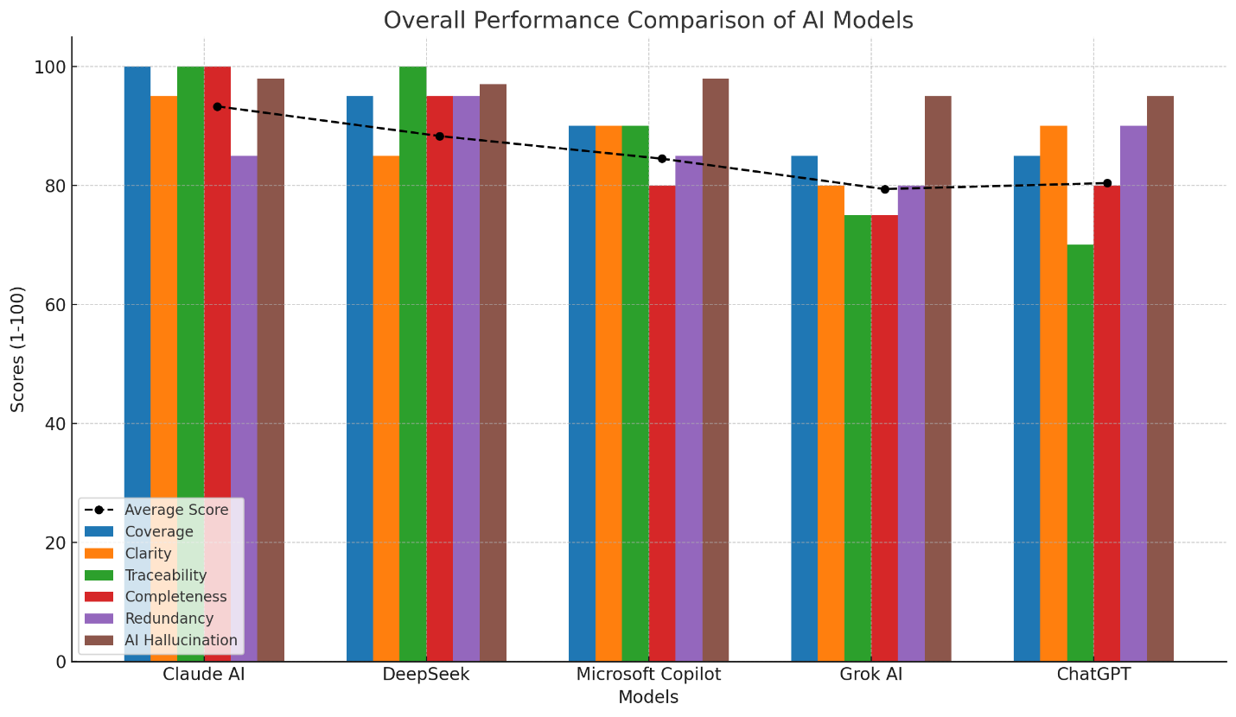
Key Insights
- Coverage:
  - Claude AI and DeepSeek scored the highest in coverage, capturing almost all the requirements outlined in the SRS document. Claude AI led with 100% coverage, capturing the broadest range of requirements, including edge cases.
  - ChatGPT scored the lowest in this area, with 85% coverage, missing key components like discounts and scholarships.
- Clarity:
  - Claude AI and Microsoft Copilot excelled in providing clear and well-structured requirements. Claude AI had a slight issue with verbosity, while Microsoft Copilot managed to strike a good balance between conciseness and detail.
  - DeepSeek and Grok AI had room for improvement, with DeepSeek being more fragmented and Grok AI lacking clear organization, especially in the presentation of functional requirements.
- Traceability:
  - Claude AI and DeepSeek were the strongest in traceability, with Claude AI providing clear references to sections of the SRS document, ensuring each requirement could be easily traced back to its source.
  - Grok AI and ChatGPT had weaker traceability, making it more difficult to verify where certain requirements originated from in the document.
- Completeness:
  - Claude AI was the best in terms of completeness, covering all critical areas including business rules, assumptions, and constraints.
  - DeepSeek and Microsoft Copilot performed well, but ChatGPT and Grok AI missed key non-functional details, such as timeline constraints and audit logging.
- Redundancy:
  - DeepSeek and ChatGPT performed the best in avoiding redundancy, ensuring that their outputs were concise without unnecessary repetition.
  - Claude AI had some minor redundancy, particularly in sections relating to user management.
- AI Hallucination:
  - Claude AI and Microsoft Copilot had the least AI hallucination, meaning they generated highly relevant and accurate data.
  - ChatGPT performed well in this area, but DeepSeek and Grok AI showed slightly higher levels of hallucination, particularly with irrelevant or fabricated content.
Recommendations
Best Overall: Claude AI
Claude AI emerges as the most reliable and comprehensive model for extracting functional and non-functional requirements. It is highly recommended for projects requiring detailed, full-scale SRS documentation due to its superior coverage, clarity, traceability, and completeness.
Best for Maximum Coverage: DeepSeek
DeepSeek is particularly strong in coverage and AI hallucination, making it a great option when thoroughness is essential. It excels in identifying and capturing detailed requirements, especially for technical aspects like encryption and security.
Best for Clear and Concise Summaries: Microsoft Copilot
Microsoft Copilot is an excellent choice for clear and concise requirement extraction. It performed well across most criteria, making it ideal for projects that require easily understandable, actionable documentation.
Avoid: Grok AI and ChatGPT
- Grok AI struggled with traceability and clarity. It is best avoided for projects requiring high precision and traceability.
- ChatGPT showed gaps in coverage and traceability, making it less suitable for comprehensive SRS tasks. It could be used for high-level summarization but not for complete extraction.
Conclusion
Based on the comprehensive analysis of all experiments, Claude AI stands out as the best-performing model, offering the best combination of coverage, clarity, traceability, and completeness. DeepSeek is a strong contender for projects that require detailed coverage, particularly for security and encryption requirements. Microsoft Copilot is best for concise, actionable documentation, while Grok AI and ChatGPT have limitations that make them less suitable for full-scale SRS extraction.

